MS.NET
Mini Project
Employee Management System
(EMS)

Document Revision History

Date | Revision No. | Author | Summary of Changes
20th Nov. 2008 | 1 | Ganesh Desai | Initial Draft
15th Dec 2008 | 1 | Anil Patil | Review
25th July 2011 | 1 | Karthik | Review after integration Process
11th May 2015 | 1 | Vaishali Kasture | Incorporating changes as per new curriculum
13th July 2016 | 1 | Vijay Vishwakarma | Incorporating changes as per new curriculum

Table of Contents
Introduction 4
Setup Checklist 4
Instructions 4
Problem Statement 5
Objective 5
Abstract of the project 5
Functional components of the project 6
Technology used: 7
Implementation 8
Summary of the functionality to be built: 8
Guidelines on the functionality to be built: 9

Introduction

This document outlines a mini project for the .NET Line of Technology (LOT). The project is to develop online Shopping Store ecommerce Application. This document contains the requirements, work flow of the system and gives guidelines on how to build the functionality gradually in each of the course modules of the .NET LOT.

Setup Checklist
Minimum System Requirements
- Intel Pentium 4 and above Windows XP, 2000 and 2003
- Memory 1 GB
- Internet Explorer 6.0 or higher
- SQL Server 2012 client and access to SQL Server 2012 server
- Visual Studio 2013

Instructions
- The code modules in the mini project should follow all the coding standards.
- Create a directory by your name in drive <drive>. In this directory, create a subdirectory MiniProject. Store your Project here.
- You can refer to your course material.
- You may also look up the help provided in the MSDN
- Since this project work will span over couple of months, you will need to take care of maintaining the code

Problem Statement

Objective
Employee information is available in flat files as comma separated values. You are required to parse the comma-separated file for employee information system and inject the same into ANY database.

ID | First  Name | Last  Name | Date  of Birth | Date  of Joining | Department | Grade | Designation | Basic | Gender | Marital  Status | Home  Address | Personal  Contact Number

Following this you will have to provide features to list the data injected, maintain the data further by enabling the user to view employee information .add individual employee details and modify existing employee information.

Other features include the abilities to search employee information based on a dynamic query building feature and finally the ability to export the employee information into a CSV / XLS format with complete employees information.

Develop the Application for the above requirement using MS.NET Technology.

Functional components of the project
Application Architecture:
Distributed web applications traditionally to be designed and built across three logical tiers:
- Database Access Layer (DAL)
- Business Logic Layer (BLL)
- Presentation Layer

The DAL refers to the database itself, the stored procedures, and the component that provides an interface to the database. The BLL refers to the component that encapsulates all the business logic of the application. And, the Presentation layer refers to the web application pages.

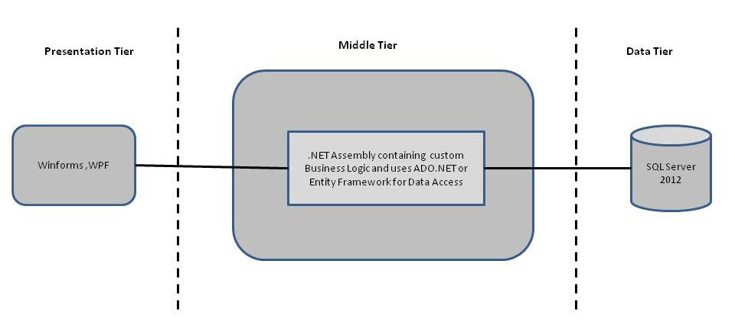

- Design guidelines
- Data access layer of 3-tier useADO.NET data access using SQL stored procedures - All the database interaction would be performed using Data Access Component. Most common methods in Data Access Component would be –
- Create Connection to the Database
- Create Command Object
- Set Command Type to Stored Procedure
- Create and Populate Parameters
- Execute the Command
- Close the Connection

Technology used:
    - Presentation Layer
      - Winforms 4.5
      - WPF 4.5

    - Business Layer
      - Business Logic Components and Services :-
        - C# 5.0

    - Database Layer
      - Databases:-
        - SQL Server 2012

Note: Saturday half day will be devoted for mini project

Implementation

Summary of the functionality to be built:
The participants need to develop the Online Shopping Cart Application by building the functionality incrementally in each of the course modules of .NET LOT.

Sr. No | Course | Duration | Functionality to be built
Sr. No | Course | (in PDs) | Functionality to be built
1 | MS SQL Server 2012 | 4 | Creating relevant database tables and stored procedures
2 | NET Framework 4.5 + C# 5.0 | 7.5 | Developing Business components (C# classes)
3 | Winforms 4.5 | 1 | Designing the user interface
4 | ADO.NET 4.5 | 3 | Integrating the DAL and BLL And PL
5 | LINQ and Entity Framework | 2 | Creating data model and data context and using LINQ to Entities
5 | WPF 4.5 | 2 | Incorporating advanced UI functionality with WPF 4.5
6 | Mini Project Presentation | 1 | The Mini Project Presentation day

Guidelines on the functionality to be built:

The functionality and components to be built in each of the course modules of .NET LOT is as follows:
- Course: SQL Server 2012
This section describes some of the basic steps involved in designing and creation of the database for the application.

Create Data Model - identify the different tables and fields that we will need, which would later be used for building the rest of the application.
Create the following tables

Table Name: Department
Column Name | Data Type | Spl. Features | Column Description
Dept_ID | int | Primary Key | Department Number. Cannot start with Zero
Dept_Name | VARCHAR(50) | Not Null | Department Name
Table Name: Employee
Column Name | Data Type | Spl. Features | Column Description
Emp_ID | VARCHAR(6) | Primary Key | Employee Number. Cannot start with Zero
Emp_First_Name | VARCHAR(25) | Not Null | Employee's First Name. E.g. Bill in Bill Gates
Emp_Last_Name | VARCHAR(25) |  | Employee's First Name. E.g. Gates in Bill Gates
Emp_Date_of_Birth | DATE | Not Null | Any valid date. Business rule is that the employee must be minimum 18 yrs old when they join the organization and their age cant exceed 58 years
Emp_Date_of_Joining | DATE | Not Null | Any valid date. Must be greater than Date of Birth
Emp_Dept_ID | int | Foreign Key
Emp_Grade | VARCHAR(2) | Not Null | M1, M2, M3…M7
Emp_Designation | VARCHAR(50)
Emp_Basic | int | Not Null
Emp_Gender | VARCHAR(1) | Not Null | Single Character to determine its M or F
Emp_Marital_Status | VARCHAR(1) | Not Null | Single Character
Emp_Home_Address | VARCHAR(100)
Emp_Contact_Num | VARCHAR(15)
Table Name: User_Master
Column Name | Data Type | Spl. Features | Column Description
UserID | VARCHAR(6) | Primary Key | UserID
UserName | VARCHAR(15) | Not Null | Cannot be less than 8 characters
UserPassword | VARCHAR(50) | Not Null | Password
UserType | VARCHAR(2) | Not Null | Supervisor or Regular user. Only a supervisor can upload the file.As of now it is only admin
Grade_Master
Column Name | Data Type | Spl. Features | Column Description
Grade_Code | Varchar(2) | Not Null | Primary Key
Description | Varchar(10) | Not Null | For Describing for example - Associates,Executive, Managers etc
Min_Salary | int | Not Null | Lower Salary band
Max_salary | int | Not Null | Upper Salary Band

- Course: Winforms 4.5,WPF 4.5
  - User having a valid user ID and password can only access the system
  - The User Interface should be Menu driven
  - Records are to be displayed in a tabular format
  - Display should be limited to 10 records per page
  - Confirmation messages are to be provided on every successful operation
  - Status indicating no of successful insertion and no rejected records to be displayed after upload operation
  - Error message to be provided on every failure operation
  - Rejected Employee Records should be logged in a separate log file with the erroneous record and the error. That log should only contain employee details.
  - Details of an employee should be displayed in a single page if required
  - Easy to use provisions (like previous, next, first, last) should be provided to navigate between records
  - Modification of any record should be possible if valid data is given.
  - Search employee records on any of the fileds - ID , First Name, Last Name , department , Grade ,Marital Status
  - Sort filtered records on any user specified column
  - Export filtered data if necessary
  - Navigate to home page at any point of time
  - Logoff from the application at any point of time

- Course: C# 5.0 and ADO.NET 4.5
  - Develop business components (C# classes) for the following functionality:
    - Department Class :- This class will contain methods to add a new department and manage existing departments
    - Employee Class :- This class will contain methods to add a new employee and manage the existing employees
    - Use Master Class :- This class will contain methods for managing users details
    - Grade Master Class :- This class will contain methods for managing Grade of the employees

You need to create Layered Architecture which comprises of PresentationLayer (winforms,WPF),Business Logic Layer (C# Classes) and DAL Layer(Using ADO.Net 4.5 or Linq and Entity Framework)

DAL Layer of ADO.NET 4.5 will include all the required code snippets for CRUD Operations.

All the CRUD operations should use SQL Server Stored Procedures(For Insert,Update,Delete & Search).

The connectionString should be stored in the configuration file only.

OR

- Course : LINQ and EF
  - Using the Database First approach of Entity Framework create a entity data model based on the database you have created in earlier steps which will consist of the following entities
    - Department :- This entity/class will hold the information about all the departments
    - Employee :- This entity/class will hold the information about all the employees
    - User_Master :- This entity/class will hold the information about all the users
    - Grade_Master :- This entity/class will hold the information about all the employees grade.
  - Using DataContext perform CRUD operations on the entity data model and using LINQ implement the required business logic (like retrieving data , sorting data, searching of data etc).

- Course: ADO.NET 4.5 ,Winforms 4.5 ,WPF 4.5
  - Integrate all screens (Winforms ,WPF ) with business components (C# classes) to complete the entire functionality.

Ask the trainer for the screenshots.

Project Evaluation Guidelines
The project it is to be evaluated based on the following five parameters:

- Proper Database Structure and UI designing as per the specifications –(15 Marks)
  - Proper Database Design and Stored Procedure
  - Visual look and feel of the UI
- Project Completion – (20 Marks)
  - Timely Completion of the project
  - Integration of all component of the system
- Defect free execution – (30 Marks)
  - Error free execution of individual modules and the whole system
  - Validation
  - Functionality as per the specified requirements
- Compliance of standard and guidelines – (15 Marks)
  - Appropriate comments entries
  - Adherence to naming conventions for classes, functions, variables and files
  - Simplicity of user interface and screen layouts
  - Maintainability of codes (for example, no one function should be more than 100 lines)
- Group Presentation and Query handling – (20 Marks)
  - Participants (Group of 3 to 4) to present the project with UML Diagrams(use case diagram and one of the sequence or activity diagram) and PPT

